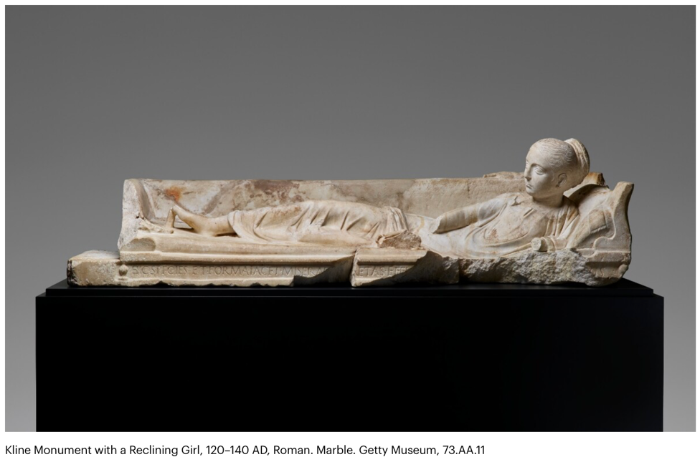

**Refine this FIA2 response**

Edit and refine

(1) to ensure logical historical sequence,

(2) to correct grammatical errors,

(3) to add some nuance to the interpretations, and

(4) to create a strong link between the content here and a sub-inquiry question.

The Kline monument with the Reclining Girl is a captivating ancient roman funerary sculpture that beautifully captures the sensitivities of Roman funerary art and especially shows what Romans thought the afterlife might offer. This monument features a reclining girl lying on a Kline, or a Roman dining couch, symbolizing the peaceful repose of the deceased. Her hairstyle dates her to the period in which emperor Hadrian ruled, between AD 117 and 139.

The sculpture serves as a poignant representation of the deceased person’s eternal rest and tranquillity in the afterlife and exemplifies the Roman practice of **commemorating** the deceased through art and sculpture (Ahdifard,2023). Days-old infants were not considered ritually unclean and, unlike older children and adults, could be buried anywhere in the city (reference). Apparently, children’s deaths were less likely to be grieved in the same intense and ritualistic manner as adults (S3).Yet,the Kline monument indicates young children were loved by their families and provided with detailed funerary monuments and markers “when the family could afford to do so” *(Maxford,2020).*

~~The treatment of children and infants was different from contemporary rituals as such deaths were very common.~~

Although the creator/ maker of the sculpture has not been determined, like the headstone that is Source 4, it still provides a reliable, informative primary source for the target audience of interested researchers, teachers and students learning about roman culture.

The sculpture was obviously created to ensure the deceased’s peaceful, joyful eternal rest and it assists answer the second sub-Inquiry question ‘*What were the Roman funerary practices with respects to children?’*

Beginning in the Augustan period – Emperor Augustus died in AD ___ - *kline* monuments were placed in tombs, either in niches or on flat bases. Eventually … these sculptures began to be used as lids for sarcophagi. This peace has grooves on the underside that would have fit the walls of a sarcophagus; it is the earliest surviving example of such a use (Getty.edu).

250 words